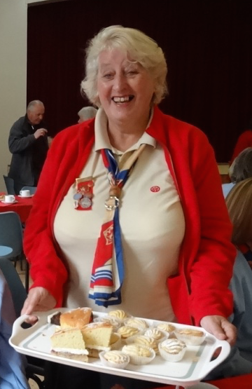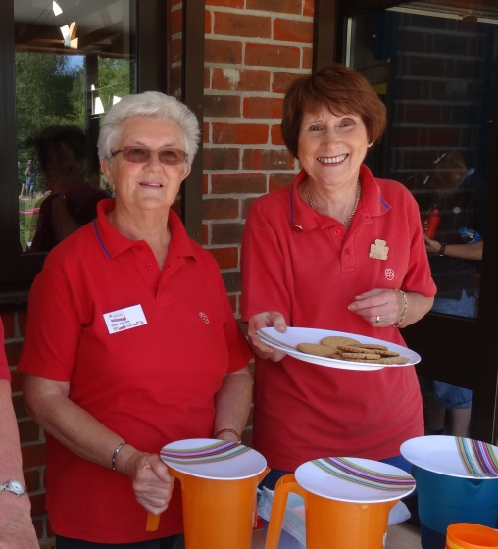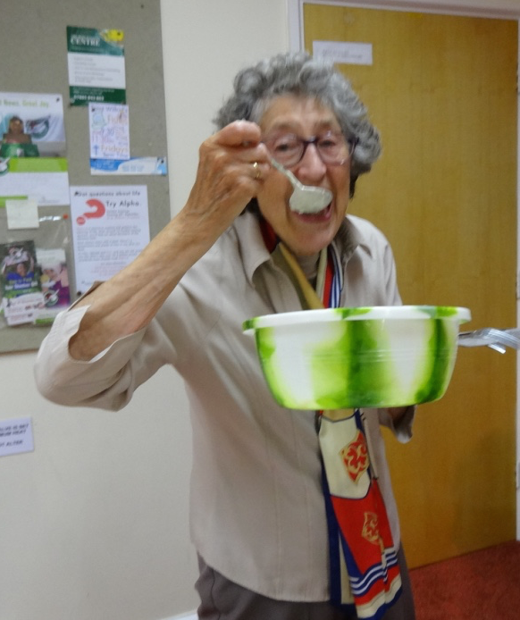

Hampshire East County Report
2015
Part Two

Hilldown Marian Vyner
We have had a very successful year, with an average of 20 members each month. In January we held our AGM and in February was a joint meeting with Portsmouth South with a Thinking Day theme. We also had a member from the American Alumnae (the equivalent of our Trefoil Guild) visit us and enjoyed afternoon tea at Gracie Anne’s Tea Room in Port Solent.
We had an airing and sharing afternoon where members brought something of interest and explained about it, a story telling afternoon when a lady told us two very interesting stories, one a fairy tale and the other about her experiences in guiding. We went on an ‘electrical journey’ (how power gets to our home) and enjoyed a talk on hedgehogs. In August we had a garden party where two Farlington Guides entertained us.
Members from Portsmouth South and Hayling Island joined us for a musical afternoon. We were shown the basic techniques of dog grooming and training and also paid a visit to the Poppy Factory in Richmond.
Our help was appreciated at various activities with Brownies and with 4 table top sales and we joined in most of the County Activities: AGM, shuffleboard, Friendship Service and the Christmas Party. We have enjoyed a very busy year.
Unfortunately we lost two members during the year, Sylvia Whitely and Jean Wiltshire. Marian
Horndean Christine Westcott
We have been delighted to see our numbers increase in both afternoon and evening groups. It’s exciting to welcome previous colleagues who are being introduced by younger members, inspiring new ideas and plans for the future.
Programme planning by two of our members proved very successful and we’ve been most interested in hearing of amazing work carried out through Fair Trade and at the New Blendworth Centre.
Members have visited Beaulieu, the Houses of Parliament and the National Service at Westminster Abbey.
Val Sewell delighted us with her memories of a WPC and we shared favourite poems and holiday treasures as well as having fun with a Beetle Drive.
We managed to raise £120 in support of a Mission to Seafarers Lent Lunch as well as supporting the Waterlooville Food Bank and the Afternooners raised funds through the year for the Portsmouth Kids Cystic Fibrosis Trust.
Our Line Dancing never quite took off but we have high hopes for the future! Chris
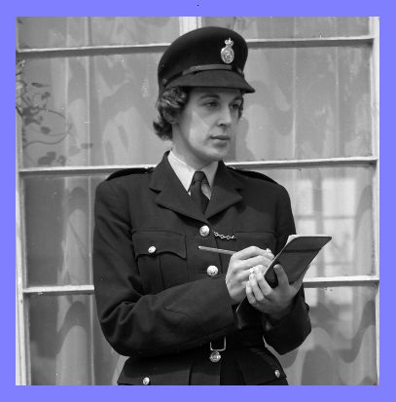
Liphook Barbara Ellis
To start off the New Year in January we held a meet, greet and planning evening, where we also found time to celebrate Burns Night, sampling Cranachan and Shortbread, with any spare time spent on a Quiz about Scotland.
February: The Trefoil Guild joined Girlguiding Liphook District at their District Thinking Day Celebrations, where they had been invited to take part in a Service at Liphook Methodist Church. Our Trefoil members were asked to carry and escort the Union Flag and take part in the candle lighting ceremony and of course we were all given the opportunity to renew our Promise.

At our regular monthly meeting we celebrated Thinking Day with Mavis Pritchard giving a presentation of her cruise, which took in the Panama Canal. We were able to see her whole experience via her laptop, books and leaflets. In addition to this, we also studied all the components of the Division Flag.

Come March we embarked on a craft evening. All the members spent the whole meeting making sequin eggs, all of which took a lot longer than we anticipated and some had to be completed at home!

In April we had a representative from Collective Legal Solutions, who aimed to teach us the pros and cons in making a will or considering L.P.As, although many other questions arose during the evening. As a result, some members have now taken action on some areas of what was learnt.

The usual May meeting time was re-arranged so that members could take the opportunity to meet during the day with an organised visit to the National Trust Gardens at Woolbeding.

In June Members gathered to enjoy a summer buffet in the Guide Hall.

As in previous years at the July meeting, some members met earlier in the evening and enjoyed a walk around the village, while others gathered to take part in activities in the hall, all gathering together for the last part of the evening.

After a summer break, in September we met again when a representative from Trading Standards came to give a talk to members and additional friends, on all aspects of their department. All those who attended were presented with information booklets, bags and no cold calling stickers for their doors.

As with every October we joined Girlguiding Liphook District to prepare for the annual Liphook Carnival. This year, the District float was based on the Disney film Frozen. Some Trefoil members dressed up and some escorted the float wearing Girlguiding Hi-Vis Waistcoats. The first part of the evening was somewhat damp. However, the float was a great success.

The girls spent their time singing songs from Frozen and the District gained its largest collection of silverware, winning The Best Children’s Float, The Best Illuminated Float and The Best Overall. We’re not sure if we will ever be able to match that again!

Our Christmas celebrations began early in November with a Christmas meal at The Half Moon in Sheet, while come December we met a week early and members enjoyed an American Supper with mulled wine and Christmas Quizzes.

In addition to our monthly meetings, various members were also able to attend the County A.G.M and the County Christmas Party. Barbara

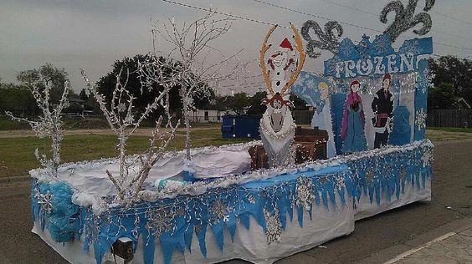
Locks Heath Barbara Sawyer
We started our year off in January with our late Christmas meal, and as usual had a very pleasant evening. (Our meetings are at the end of each month, so we don’t meet in December).
During the year we have had talks from the Fire Brigade, the Police and one of our own members gave us an interesting presentation on saving money! Another month we had a speaker to talk about the Warsash Roll of Honour; something some of us had little knowledge of beforehand.
July saw us having our usual barbeque and in the autumn we again prepared shoe boxes for the elderly, a very satisfying activity.
The Division held a weekend away for Brownies and Rainbows and we were asked to help with some of the activities and refreshments, which we willing did, and thoroughly enjoyed ourselves in the process.
Sadly one of our members died after a long battle with illness, but she will always be fondly remembered. Barbara
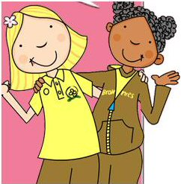
Meon Valley Sarah Mills
The Meon Valley Trefoil Guild finished 2014 with a most enjoyable Skittles and Bar Snack evening at the Milburys on 9th December 2014.
Following the decision to change our meeting evenings from a Tuesday to a Monday, 17 members met on 12th January to hear one of our members, Jane Lawrence, give a very informative and amusing talk, plus pictures, on her trip to China.
In February, we had an enjoyable evening at the Mayflower Theatre, Southampton for the West End production of the musical “The Bodyguard” featuring powerful singing and dancing from an excellent cast, including X-Factor winner Alexandra Burke.
Once again one of our members, Veronica Smith, provided her expertise for our March meeting and helped 13 members to achieve some pretty cake toppers for Easter.
In April, our retired local florist, Hazel, gave another of her excellent flower arranging demonstrations and members were given the treat of one of her lovely arrangements to take home.
Member, Denise Lord, organized the May meeting and an evening of ‘competitive’ shuffleboard included the addition of a Bishops Waltham jigsaw puzzle which had 8 members ‘desperate’ to finish before the end of the evening. Needless to say, this proved impossible, although considering the small pieces and endless bunting, cars, brickwork and greenery, we did rather well. Hopefully, Denise finished the puzzle at home!
On Saturday 13th June, a gloomy start to the day turned into sunshine by the time 10 members, plus guests boarded the Richmond Canal Boat for a trip on the Chichester Canal. The cream tea was excellent and the crew friendly and happy to answer questions. Very pretty scenery and plenty of birdlife including a proud looking heron that seemed to like the look of us! Half way through the trip we were able to get off and stretch our legs to see the view that Turner had painted. The boat had been booked for our exclusive use, but in the best traditions of guiding, we did give a lift back to Chichester to a man on crutches!
Our Annual General Meeting took place on 15th June with 12 members in attendance. The election of officers included the appointment of Sarah Mills as our new chair and a very big “thank you” to Iris for all her hard work during her period of chairing Meon Valley.
The last meeting before the summer break was a trip to Southsea in July for fish/chips and a game of crazy golf. However, once again, the weather scuppered the game of crazy golf so members enjoyed a chat over a meal.
Following the summer break, 12 members met on 14th September to hear the exploits of one of our local doctors, Dr. Tim Frank who, in memory of his late wife, has organised, and taken part in, some pretty hair-raising sponsored cycle treks throughout Europe in order to raise money for Cancer Research UK. Dr. Frank continues in his efforts to raise money and information on the 2016 challenge “Home to Rome” can be found on the website ‘Inspired Living’ http://www.inspiredliving.org.uk/
On October 12th, 8 members met for an evening organised by two of our members where some expert fingers helped out the more “fingers and thumbs” members to cross-stitch cards with a Christmas theme. Some of us are still trying to complete a card – well there is always Christmas 2016!!
15 members met on 9th November when Hazel provided masses of foliage and sparkly bits to help us complete some pretty good looking door hangers for Christmas.
This brings us once again to the Christmas meeting when we joined together for good food, conversation and laughter at Banks Restaurant, Bishops Waltham.
An afternoon group has held several enjoyable sessions since the decision at the AGM to test the water on whether there would be sufficient support for this group within our Guild. More sessions are planned and we hope that the afternoon group will prove to be a successful addition to activities within our area. Sarah
Mystic Hilary Hetherington
We are a new Guild in Gosport North and our name was chosen as it used to be the name of a Ranger unit many years ago. Our first meeting was in September 2015 and we meet bi monthly, as the majority of us are still actively Guiding .
Like all guilds we hope to grow our membership during this coming year. During our first meeting, we were pleased to welcome Margaret Hunt and Janet Biddlecombe, from County Trefoil, who helped us with lots of information regarding Trefoil. Once business was completed, we all book folded a Hedgehog.
Our second meeting was in November when we invited a local Scottish Dancing group. A great deal of fun was had by us all as we got to take part in lots of the dances. It was at this meeting that Janet Biddlecombe and Anne Naish presented our Guild with our formal Registration Certificate from HQ.
We are all looking forward to the coming year as part of Hampshire East Trefoil. Hilary
Petersfield Margaret Hawkes
We began the year with our usual annual dinner. with guests, at the Half Moon in Petersfield. Time to also meet old friends of Petersfield Guiding.
In February we visited our Chairman Margaret’s house; the theme for conversation was ‘Your First Job’ and the story behind it. We learned some surprising things about each other and had a few laughs as well.
March saw us taking the husbands and friends out for a supper and skittles evening. Exhausting (oh to be young again!!). April found us decorating a hat for Easter and a May walk to Hindhead finished with supper.
June should have been a barbeque at Queen Elizabeth Country Park but it was rained off, sadly. In July we had a Taboo evening at Gill’s house. This also gave us time to plan our September holiday. The August meeting was taken up by a trip to the Mayflower theatre to see Mack and Mabel – brilliant.
In September we stayed at Foxlease for our annual holiday together. Marjory took us round all her old haunts and this was enjoyed by all. We also celebrated our Chairman’s 80th birthday at Woolbeding National Trust with a cream tea.
Our October meeting was a Caribbean evening at Rosemary’s house where we were asked to cook something from this country for all to try. Diets go out of the window at this time. November was a games evening and we finished the year with ‘Marjorie’s Christmas Madness’.
Margaret
Portsmouth South Chris Lavis
2015 was another busy year in the life of PSTG. We have quizzed, created, played and nattered – the latter a seemingly vital element in any activity.
We have made creatures from teasels, folded paper during Origami and sewn/stuck for Christmas decorations. Our brains have been tested with a Photographic quiz on public memorials and statues in and around Portsmouth, our musical ears challenged by a very funny ‘Name That Tune’ session – with everyone having to perform for the guessers. Ludo, played on a large scale board, really brought out the inner competitor.
We were educated and informed on the nuances of sign language and lip reading for the hard of hearing. Many people admitted that they could hear better when they could see the speaker. Later in the year we were visited by Hearing Dogs for the Deaf who demonstrated their skills.
Members have sewn squares for the Dockyard Sail project, attended First Response Courses and have had a meal together. Activities organised by Hampshire East have been well supported too.
Fund raising for various charities and for our own funds have taken place during the year. Garden Parties, collections and running a stall at the local May Fayre have been successful.
Two members of long standing in the Guild have sadly died during the year. Winnie Beer, well known within the GGA, both as historian and photographer, passed away peacefully at home. May Dash was a proficient pianist who played for several choirs and the Portsmouth Music Festivals. The Guild was asked to sing Taps at both the very moving services and we were proud to be able to do so. Their influence lives on, photos and singing being part of most meetings.
Jennifer Dalmeny was presented with her Trefoil Brooch by our County Chairman, Margaret, during the year.
As the year drew to a conclusion, we were visited by the Pompey Pluckers. They brought along enough spare instruments for everyone, who wished, to learn chords, play simple tunes and sing-a-long.
We look forward to the next year and maybe some new members and the challenges it will bring. Chris

11th Gosport Mary Tillman
We meet each week and have the advantage of the ‘Out of Doors’ when the weather is suitable. We cook, have a variety of crafts, sing, and play board games, card games and homemade games. We read stories and poetry,
During the year we collect gifts to fill shoe boxes for under privileged children abroad. This year we reached our target for the first time and filled 300 boxes. The Rotarians collected them and we had a sing-song with their Guitars and they gave us each a box of Chocolates.
We invited Parents and friends to join us for our Service at St Matthew’s and, as a result, Bridgemary and Rowner Guild produced a large amount of knitting to help us fill the shoe boxes. We use any excuse to celebrate Birthdays, Thinking Day, Easter, Christmas etc. We enjoyed the Pantomime at Petersfield by the Winton Players, which was excellent as usual, and we were invited to enjoy a BBQ and games in the garden of Lynne and Peter Maxwell.
In October a kind friend paid for us to go to the Isle of Wight. We travelled by catamaran, took the train up the Pier and then the buses to the Waltzing Waters, which was amazing, and then to a Donkey sanctuary where we adopted a donkey called Angelica. We all cuddled her- to the amazement of the staff who said she normally kicked anyone who went near!
We are grateful to so many people who have supported us in so many different ways this year. Mary
Hampshire East Lones Margaret Cherrett
This year the Lone Trefoil Guild welcomed Louisa in the spring but were saddened by the death of Edith in July. ‘Round Robin’ letters didn’t work, so we now have 4 postal meetings a year, one for each season. Hard Copies are sent to the individual members and Eunice publishes them on the Website for everyone to see. Lones, who are mobile, enjoy joining with local Guilds from time to time and we are grateful for the invitations we receive.
It would be nice to have a few more members; being a ‘Lone’ may appeal to house bound ladies or those who are too active to attend regular meetings! Margaret

HAMPSHIRE EAST TREFOIL GUILD

Statement of Income & Expenditure for Financial Year Ending 31st December 2015

LLOYDS BANK TREASURERS ACCOUNT Bank 1

INCOME £ EXPENDITURE £
Balance B/fwd 2014 1,912.64
Census & Admin 5,244.00 Census 4,140.00

SWR AM Bath 334.00 SWR AM Bath 334.00
Returned from Region 70.00 Refunded to Guilds 70.00
Coach to Bath 536.50 Coach to Bath 536.50
HE County Reports 184.00
Trefoil Handbooks 7.50
Gift, flowers,Trefoil Badge 81.84

H/East AM 138.00 H/East AM expenses 241.17
Raffle 91.50

Shuffleboard 600.50 Shuffleboard expenses 531.84
Food refunds 16.00
Raffle 98.50 Raffle prizes 7.99 incl. in exps

Sausage Sizzle 328.00 Sausage Sizzle expenses 255.16
Return of security deposit 50.00 Security Deposit for Hall 50.00

Friendship Service Friendship Service expense 97.00
Collection 222.00 All donated to Teenage
& donations for cakes 3.00 Cancer Trust 225.00

Christmas Party 504.00 Party expenses 278.09
2 refunds given 8.00
Security deposit refund 100.00 Security Deposit paid 100.00

First Aid & Treasurers Training 136.55
Royalties from sale of

New Trefoil Song Book 32.00 Equipment, Amplifier 34.83
Region meeting Foxlease 7.50

Website annual fees 105.00
E.Conybeare travel 5.60

INCOME £ EXPENDITURE £
Hall hire & expenses
For Chair & Secretaries
meetings 2015 92.57
SW Region Reports 2015/15 93.00
Expenses:
Lones Guild 40.00
J Bowden (Sec) 78.49
M Hunt (Chair) 83.44
J Gilbert (Treasurer) 35.85
V Sewell (President) 7.20
C Richards (President) 3.60
Guild visits mileage exp.
M Hunt, V Sewell, C Richards 46.10
A Naish, J Biddlecombe
(Dev Co-ords) 40.40
A Stouse DHV, Voyage 12.44

Income for 2015 8,352.00 Expenditure for 2015 7,988.67
Less expenditure 7,988.67
Surplus or (Deficit) for yr 363.33
Bank 1 Bal b/fwd 2014 1,912.64
Bal in hand at year end 2,275.97
2 cheques unpresented 103.00 Not presented at 31.12.15
2,378.97 (Bank Statement Treasurers a/c)

INSTANT ACCESS
A/c Bank 2 (previously 30 day a/c)
Bank 2 Bal b/fwd 2014 2,095.18
Interest rec’d 2015 1.06
Bal in hand at year end 2,096.24 No monies used from this account in 2015
Total in a/cs at year end 4,372.21
Date 12.01.16 Date 19.01.16

The receipt and payment accounts have been examined by myself and are in accordance with the Guilds’ books and vouchers. The Income and Expenditure as shown are to the best of my knowledge authorised transactions.
Date 25.01.16

The aims and objectives of the Trefoil Guild are:

• To keep alive among members the spirit of the Guide and Scout Promises and Laws

• To carry that spirit into the communities in which members live and work

• To give practical, financial and moral support to Guiding and Scouting

Our mission

The Trefoil Guild offers members personal and social opportunities whilst supporting Guiding and Scouting.

The Trefoil Guild Promise

I promise that I will do my best:
To be true to myself and develop my beliefs,
To serve the Queen and my community,
To help other people and
To keep the Guide Law.

Hampshire East’s Trefoil Song Book
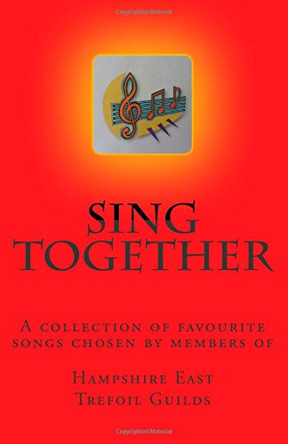
is available from
Amazon
(www.amazon.co.uk)
Price: £5.00
(postage free for orders over £10.00)

Royalties will be donated to
Hampshire East Trefoil Guild

Sing Together
is a collection of over 200 favourite songs chosen by
members of Hampshire East Trefoil Guilds

