|  |
| --- |
| **Hampshire East Annual Report 2015 Part One** |



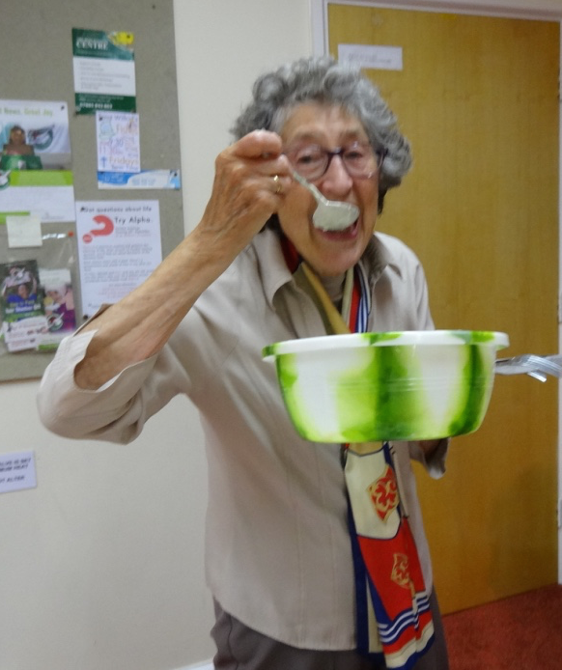

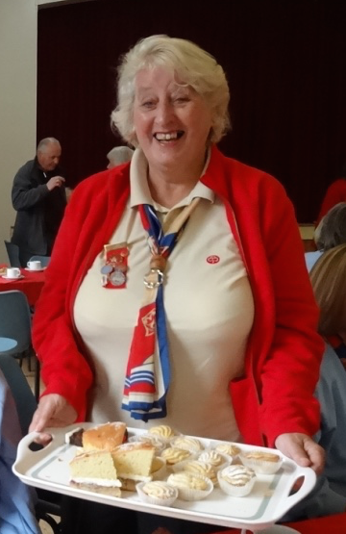

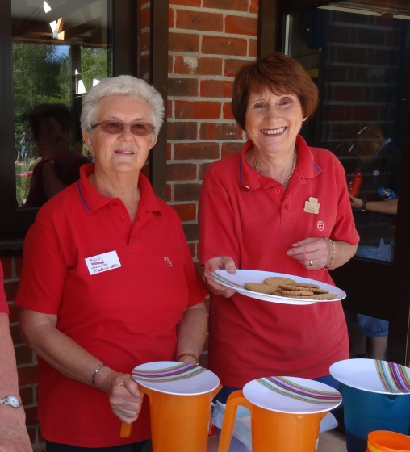

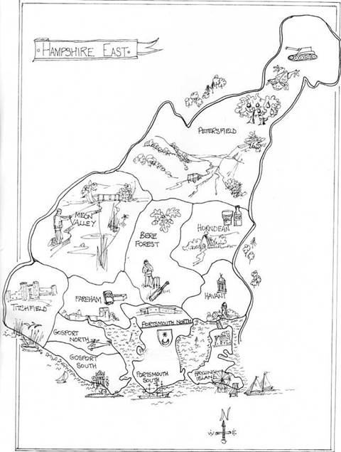



Trefoil Guild is guiding

for adults – fun,

friendship and making a

difference!

In Hampshire East there are 18 Guilds with

327 members, including a

Lone members’ group and a disabled members’ group.

Trefoil members live the spirit of Guiding and Scouting in their own community.



**President’s Letter Chris Richards**

It's nearly a year since Margaret asked me to become County President.

During this time I have visited quite a few Guilds and been warmly welcomed. Each Guild is unique and I have loved joining in the activities.

It has had a few problems - trying to find one Guild I landed up in the allotments.  Another time found myself, with Margaret, right road, wrong end of town, but that’s Guiding.

I hope you have a happy and successful 2016, and I can visit a lot more of you.

**Chris**



**County Chairman’s Report Margaret  Hunt**

During the year Chris Richards and I have had the pleasure of joining Units at their meetings and the following Annual Reports illustrate the Friendship, Fun and Laughter that can be enjoyed in Trefoil Activities. Several Guilds have extended their meetings to an afternoon and evening session per month. Interest groups, such as books, sewing, lunch, walking and theatre are forming, to allow for an extended programme. Invitations are made to neighbouring Guilds to share in activities; these have included a Scottish Dancing display, a Harvest Service with supper and a Gilbert and Sullivan musical evening.

Outings have included the Poppy factory with a trip on the Thames, Canal trips and days at the seaside. Speakers have been invited to talk on various subjects - Cycling through Europe, Street Pastor, Dog grooming, endangered Hedgehogs and the history of the local area, including a walk to illustrate it. Added to this, activities such as the ‘Portsmouth Pluckers’, Horse Racing as at Ascot complete with Hats, Treasure Hunts, speed Scrabble and singing - to name a few, were enjoyed.

Contact has been made with our International links in France, Canada and Australia and a visit by a Trefoil friend and husband from the USA was a good excuse to enjoy a traditional English Tea!

Food plays a big part in County Activities and there has been the usual Sausage Sizzle and Campfire held at Portsmouth’s Camp Site (again in the rain) and a Shuffleboard evening with fish and chips. The Friendship Service and Christmas Party are also a time when we share delicious cakes made by members of the Guilds. The Service allowed us to hear of the work that the Teenage Cancer Trust does and the collection went to them. The Christmas Party allowed members to donate mainstay items to Food Banks whilst individual Guilds supported many other Charities throughout the year. The cakes, raffles etc are therefore used to think of others.

We have a new Guild where most of the members are Leaders in Girlguiding. The Lones, though few, enjoy contact through newsletters and invitations to local groups and the Disabled group enjoys a full and active programme weekly, which they illustrated at their Annual Service. Sadly, we have lost several members this year, all of whom have given years of service to Guiding.

County Girlguiding invited us to mount displays of the Trefoil Guild at reviews and training days to promote the Trefoil Guild. This has enabled publicity for the Voyage Award and the Dark Horse Venture, resulting in a growing interest in what we do. We are grateful to County Trainers, who have enabled us to take the First Response course and the Girlguiding Treasurer’s programme.

During the year, I was please to present Trefoil Brooches to Jennifer Dalmeney for her support over many years to a fellow member of Guiding and to Mary Tillman in appreciation for a lifetime commitment to the Disabled Unit.

None of the above could happen, and be so successful, without the continuing support, cheerfulness and expertise of the County Team, the Officers of the Guilds and the many Ladies who step forward to take their turn in arranging the events described above.

Due to the 5 year cycle of appointments, we have seen some changes within the County and I would like to take this opportunity to thank Barbara Hall for her time as PR and the Ladies who have given up office in their Guilds. Your commitment and enthusiasm is appreciated by all. In turn I would like to welcome and give thanks to those Ladies who have taken on those roles for the future.

Thank you all for your Friendship and for all you do throughout the year. **Margaret**

 **Co-ordinators’ Reports**

**Programme & Development Anne Naish**

**Janet Biddlecombe**

As previously planned, during the spring of 2015, invitations went out to several Guide leaders throughout the County for a 'Trefoil Taster Session' to be held in April at Waterlooville. Unfortunately, the response was not as hoped and the event was cancelled but the five people who did respond were invited to an introduction evening with a slide show and talk at Bere Forest Guild, where they later joined members for a barbecue. This has resulted in some new younger members for Bere Forest Guild.

During the rest of the year we have tried to be at as many Guiding events as possible and have chatted with leaders, and in some cases ex-leaders, encouraging them to consider joining existing Guilds or forming their own.

After the Award Presentations at Boathouse 7, Janet chatted with a group of Guiders from Gosport, who then decided to form a new Guild. So Margaret and Janet went to their first meeting in Gosport where it was agreed that they call themselves 'Mystic' after a previous Gosport Sea Ranger Unit. In November, Anne and Janet went along to their meeting to present their Registration Certificate and spent an enjoyable evening Scottish Dancing with them.

At the time of writing, we have a promotional display in the County Resource Centre window in Fareham Shopping Centre. This will be moved to the local Library in February.

Programmes throughout the County are varied and we look forward to seeing your Guild Programmes for 2016. We have some County events that have been popular and are repeated most years and it would be good to have some new activities that would be suitable for a County event so that we could ring the changes. Do please let us know of any ideas that you may have so they could be considered for the future. Anne and Janet



**Voyage Award & Dark Horse Venture Avril Stouse**

Membershave continued to work on both awards throughout the year with three currently completing activities for the Dark Horse Venture and eleven members actively challenging themselves through the Voyage Award.

It is unfortunate that several, who were working on the Dark Horse Venture and who are so close to completing, seem to have fallen by the wayside. Please reconsider, if you fall into that category, so that your efforts can be acknowledged by the award of a certificate.

Congratulations to:

* Gillian Howat (Petersfield) for completion of the Dark Horse Venture Award Gold Level
* Avril Stouse (Hayling Island) for completion of the Voyage Award Silver Level.
* Rene Seaman (Fareham Guild) on being awarded her Voyage Award Bronze Certificate and Badge in March.

The activities for both awards have been many and varied and have included:

study of comparative religions, family history research, getting to grips with new computer systems, painting, keeping fit by walking and work outs at the gym, taking on new roles, exploring new areas, setting up book groups, spreading the word about the Trefoil Guild, encouraging new members.

There are many more activities being undertaken and the choice is yours. So, if you have not yet joined the Voyagers or Venturers, why not give it a go in 2016.

Let’s keep Hampshire East ‘Venturing’ and ‘Voyaging’ along. **Avril**



**County & Just Friends Website Eunice Conybeare**

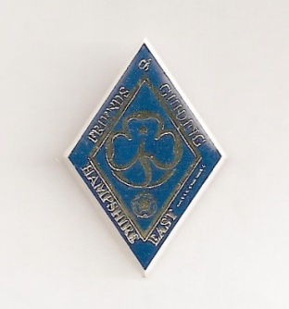

Currently (December 2015) we have 217 members registered on the website. This is an increase of 23 since last year’s report. 11 of these are new members from Mystic. Of this total, 13 are Just Friends only and 60 are both Trefoil and Just Friends. The total also includes 17 Commissioners.

The number of members actually using the website continues to be disappointing and the information cards produced last year do not appear to have had any lasting effect.

Memories, Photos, News, Forms, Future Events, Activities, Speakers, Voyage Award and Guild Programmes sections are constantly updated with both Trefoil and Just Friends current information.

Once again, I must emphasise that the website relies on receiving information, photos and articles from Guilds and Friends. If these are not forthcoming, it cannot function as a useful tool, so please, please, if you have not contributed before, make 2016 your year and if you have contributed, thank you for your support and please keep on doing so. **Eunice**

C:\Program Files\Microsoft Office\MEDIA\CAGCAT10\j0195384.wmf

**County Public Relations Rene Seaman**

A report and photo of our County AGM had been sent in to the News but was not published. Publicity notices in November also failed to be put on local community notice boards. In November Barbara handed on the PR mantle to me. It had been a difficult year for Barbara due to ill health,

In November Fareham Guild took part for first time Charity Christmas Trees Festival. Their tree, which was decorated for Honey Pot Child Carers’ Charity, won the people’s choice vote and we were awarded £25 for this charity and a Judges’ Commendation Certificate. This showed how the Trefoil Guild can get involved in the Community. There was a mention in the News, which was good. If any Guilds are involved in Community events it would be good to have details and photos to send to the News. Many Guilds do support local Guiding units and charities.

Guild members also helped with the Christmas Grotto and maybe this was a missed opportunity to promote the Trefoil Guild. Fareham planted memory bulbs opposite Ferneham Hall for everyone to enjoy.

New Year 2016 saw the Trefoil board on display in Fareham library for 2 weeks and a Meet and Greet Day in February, with a chance for those interested to talk to Trefoil members and pick up information. The Voyage board was there too. It is hoped that other Guilds may be willing to arrange similar displays

I hope that in 2016 we can promote Trefoil Guilds in the Community. Rene



**Guild Reports**

**Bere Forest**

The year started with Hannah Lawton giving a presentation to the Guild on 'How Girlguiding affected the lives of women in the post the war period'. This was for her Queen's Guide Award.

We welcomed Margaret Hunt, our County Chair, and Division Commissioners and Guiders to our AGM in February. This was followed by Thinking Day activities and refreshments.

As 2015 marked our 25th Anniversary we had a silver celebration in June, the month the Guild was registered in 1990. It was a relaxed and fun evening as we looked back over the many log books and photo albums and relived the memories. Remarkably, we still have all but one of our Guild Chairmen as members and the original Chairman, Maureen Judd, cut our celebration cake and our then newest member, Joan Goble, made her promise.

During the year we have supported the Division by making and serving cakes at their Thinking Day sponsored Danceathon in aid of Teenage Cancer Trust and in memory of a young guider from Denmead. This raised over £2,222. We supported the Lifeguards by knitting numerous lifeguard teddy bears which they sell to raise funds. We helped with the activities at the Sandy Acres Musical Fun Day and also provided lunches for the helpers.

Our activities this year have included a talk on the local history of Purbrook, a Skittles Evening at The Kings Head at Wickham, a barbecue at Waterlooville HQ, a summer evening quiz around Rowlands Castle, a craft evening and our take on a Guide 'Science Go for it' with several experiments for members to have a go at. Maureen Judd gave a flower demonstration with the arrangements depicting her life in Guiding. During August we had a very interesting trip to Southwick House Map Room and Museum followed by a delicious cream tea. In December we enjoyed a Christmas meal together at the Horse and Jockey and finished the year with a Christmas Party on our normal guild evening in December.

As well as our normal meetings we have had several morning walks ending with coffee at a local hostelry. We also joined with Horndean Guild for a Bluebell walk and talk at Clanfield. Members attended Christchurch, Portsdown, for the D Day Service and Remembrance Sunday Service.

Members have attended all the County events ie. County AGM, Shuffleboard, the Sausage sizzle which we hosted at Sandy Acres, the Friendship Service in October and the County Christmas Party at Bedhampton.

We have welcomed some new members during the year including Joan's husband David who is kindly taking over as treasurer in the New Year.

Sadly, one of our members, Roy Grayson, passed away at the end of November. He will be greatly missed. Members decided to have a collection at our Christmas Party when £186 was raised. This has been donated to The Rowans and Macmillan, each receiving £93 in Roy's memory.

Anne



**Bridgemary & Rowner Lynne Maxwell**   
In January, reluctantly, I accepted the challenge of becoming Chairman of our Guild. Eileen Cook is a hard act to follow. However, I have had a lovely year and our Guild Members have been supportive and great fun.

We celebrated “Thinking Day” with an Italian Evening, enjoying Italian food and being serenaded by Pavarotti. Our Candle Ceremony was lovely; we all lit a candle to remind us of someone who had meant a great deal to us in Guiding and who are, sadly, no longer with us.

All went well until the 22nd candle was lit when it set off the fire alarm!! I raised my eyes to the ceiling and saw a fire detection device. I said a quick prayer that it was not a “sprinkler” device and was grateful that it was not! Our members were really kind and said it was “fun” and Sharon Butcher kindly rang the Scouter in charge of the Hall so that we were able to turn off that dreadful sound.

We were lucky to have an “Easter Flower Decoration” demonstration by Gwen Potter, and again, in October, Gwen showed us another of her many talents by demonstrating a Christmas dried flower display and then we all created our own arrangement.

Our June meeting was at Stokes Bay having a delicious meal out overlooking the Solent. This was followed, in July, by a "Keep Fit” evening.

August found us at the Wheel House in Hill Head. Unfortunately, the weather was horrendous. The gales blew the sea over the sea wall and it joined with the rain to make us soaked so that we all moved a whole lot faster than usual to get into the building- only slightly soggy! Nevertheless, we had a really happy day and had the joy of welcoming one of the “Lone Trefoils", Anne Greenwood, to share our day.

Ann Bardwell made us use our brains with a Speed Scrabble evening and then gave us another evening with the “Deal or No Deal” game that was simply hilarious.

Several members knitted dozens of pencil cases, hats, jumpers and toys to help 11th Gosport Trefoils fill their shoe boxes for Romania, and we received a really warm welcome when we popped into their meeting to deliver our gifts.

In November, Margaret Hunt came and, with Bob's help, led us in some” Old Time Dancing". Everyone really enjoyed that evening. We were pleased that Chris Richards, our County Trefoil President, was able to join us and share our Christmas Party food too.

I would like to thank all our Members for joining in at Unit and County level and making Trefoil Guild such fun.

Lynne



**Crofton Janet Biddlecombe**

When I began to look back at what Crofton Trefoil had done over the last year it added up to another very busy year.

Members always enjoy their monthly meetings and this year we had time to make crafts, lots of tea parties, a sing song as well as a trip to the Poppy Factory in Richmond and miniature railway rides. But I am proud that we have been able to join with our local community joining in a Macmillan Coffee morning at Hill Head Sailing Club. We also raised money for toilet twinning and Samaritan Purses through the parish church.

As part of Crofton District, we helped with the planting of daffodils around the Guide Centre and worked with Units. We have also attended the Division AGM and Gosport South’s Division President’s Challenge Day at Sandy Acres.

We joined with other Trefoils at a Scottish dancing afternoon and ceilidh.

Let us hope that next year we will do more and invite other Trefoils to join us in some of our activities.

We have been busy joining in the Trefoil County events at the Sausage Sizzle, Shuffleboard, AGM, Services and Christmas Party, whilst a small contingent had the day in Bath for the Region AGM and three members had a lovely break in Ireland to attend the National AGM held in Londonderry where a visit to Lorne was much enjoyed.

We even joined with our brother/sister scouts at the St George’s Day Parade in Gosport, attended the Gang Show and joined in the Remembrance Sunday Parade in the village.

We were pleased to be able to support our local campsite at Sandy Acres by attending a campfire and pamper day.

Twelve members have joined ‘Just Friends’. Thank you to True Friends who enable us to join with old Guiding friends at the annual Lychees Thinking Day Lunch, the St.George’s Day tea and a trip to Hilliers Garden and Sandy Acres.

To top it all, we still run our extra book, walking, lunch, sewing, gardening and DVD/Cinema clubs during the month. We did have a very successful ten pin bowling club until the Collingwood alley was closed down so we are now searching for a new venue.

Thank you to Karen and Jane, my secretary and treasurer, for their continued support and hard work. Janet

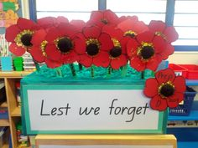

**Emsworth Margaret Vahey**

Emsworth has had another busy and enjoyable year with one big change. After all her hard work, Pauline has been persuaded that she needs to take more care of herself and Marion Lea is now our Secretary.

We reminded the people of Emsworth that we still existed by flying the World Flag in the square on Thinking Day – interest- but still no new members. Due to age and ill health our numbers are falling but we do have two recruits, both of whom have taken the plunge and have already remade their Promise as Trefoil members.

Stella Rutter was our speaker in March. A female plane and equipment designer during the 2nd World War and hostess of an important meeting the night before D Day so an amazing story, which due to secrecy laws, she is only now allowed to tell.

April and it was ‘Chile a Weird Life’. Heather A. told us about her stay in South America. We learnt about the Geography of this long thin Country and the differing cultural customs. We learnt more about Emsworth following Heather B’s quiz - quite a difficult one when we thought we knew the place!

Our new Division Commissioner came to visit us in April and some of us helped at the Picnic/Activity Day in the Queen Elizabeth Country Park. It was very wet but very enjoyable. Some of us also spent a busy and equally enjoyable day at Sandy Acres with Rainbows and Brownies on another Activity Day.

More walking during our annual Foxlease stay as we re-explored the grounds and made friends with some students who were camping there working for their Duke of Edinburgh Awards. They were a bit surprised when some “old ladies” showed them how to read a map and saved them from getting lost. On the way home we stopped at Mottisfont Abbey, looked around and had a rather wet coffee break.

July was our Skittles evening at the Barley Mow, Walderton – a good game and buffet. More food in August when we met at Margaret’s for a BBQ.

In September Pat told us about her work as a volunteer with the National Trust and Havant Light Opera came to us in October. It was a lovely concert, very well attended and thoroughly enjoyed by all, as was the Buffet, raising a good sum for the Rowans Hospice.

Audrey organised a games evening in November, then we were eating again when we had our Christmas Meal at the Wheelwright Arms in Havant.

We have started a jigsaw library, and our weekly Art Group continues and we are told, by Margaret, that we are getting better and everyone has a good time.

Margaret



**Fareham Shirley Boyd**

JANUARY: AGM followed by Discussion and Plans for the year ahead

FEBRUARY: Scottish Country Dancing Ceilidh demonstration when other Guild Members had an opportunity to dance. Thinking Day meal. Rene‘s Camper trip tales.

MARCH: Games afternoon. Easter Bonnet Parade. Members attended the County AGM

APRIL: Speaker told us about Honey Pot “one childhood-one chance” . Members went to the Gang Show at Ferneham Hall and Hants West Showtime at Southampton Guildhall. Walk with lunch and Region AGM Bath.

MAY: Community Action talk, County Shuffleboard. Support for Guides Table Plant Sale

JUNE: Show and tell about hobbies /Voyage Award. Rene enjoyed Londonderry AGM holiday. Group of members met for Walkaround Gosport Workhouse Lake and lunching at Lakeside

JULY: Some went to the County Sausage Sizzle. Wheelhouse fish & chips day with a silent auction to raise funds, crocus display and games, quiz, strolls.

AUGUST: Group met up with Bognor Guild in Chichester for a fish & chip cruise on the Chichester Canal. A small group went on a coach trip to Bridport/West Bay. Some also had a Chinese lunch in Gosport.

SEPTEMBER: McMillan Tea when County Chairman, Margaret, joined us. We raised £58

OCTOBER:“ Days for Girls” talk and making up sanitary packages

NOVEMBER: We hosted the County Friendship Service and decorated a Christmas tree, themed on Honey Pot .We donated our card money this year to this charity and filled 6 decorated shoe boxes with small gifts. Alaska Travels talk and Christmas fun

DECEMBER: Meal at Red Lion Stubbington.

OUTINGS: Visits to Gosport Gang Show and Hampshire West Showtime. Day trip to Bridport and West Bay.

Meet up with Bognor Guild and an afternoon with fish and chip lunch on boat cruise on Chichester canal. AGM Bath. Rene went to AGM Londonderry

WALKS/ACTIVITIES:

Games session, bowling, skittles and boules, Thinking Day meal, Chinese lunch, Christmas Dinner. Scottish Ceilidh , Wheelhouse day on seafront with fish and chips, crocus bulbs were planted in grassed area opposite Ferneham Hall in memory of Phyl Hathaway and previous members

Strolls around Gosport Workhouse Lake and L O S with meals, a games session, bowling, skittles and boules, Thinking Day meal, Chinese lunch,

TALKS/SPEAKERS:

Included Rene’s camper trip, Honeypot , Community Action ,Basics bank , Days for girls, Alaska travels. Donations made for charity speakers. GUIDING Member, Di Harding, visited units as part of a Voyage challenge. Shirley helped with units and Pack Holiday and members gave support in the shop.

CHARITY:

25 shoeboxes were filled for Rotary appeal and £25 donated to assist transport cost, plus 6 shoe boxes were filled with gifts for child carers to be distributed by Honeypot Charity. Tree decorated on Honey Pot theme with a share of charity collection going to the Honey Pot Charity. Knitting for Rocky stall and making Smoothie hats.

**Another busy year for Fareham Trefoil Guild.** Shirley



**Gomer Barbara Hall**

2015 has been a very difficult year for me as the 6 weeks that I spent in Southampton Hospital, with the last 2 weeks being moved to Queen Alexandra Hospital, was a very confusing and problematical time but I am pleased to say that everything has turned out well and, although I am told that I have another 6 months to go, life looks a little more rosy now.

I am so grateful that I was able to attend the Guiding awards evening, thanks to Marie Anthony and Pam Marsden who pushed me over to Portsmouth in a wheelchair in the Gosport Ferry, ably accompanied by members of Crofton and Bere Forest Guild members. I felt a bit like the Queen.

Another member of our Guild had a very prolonged stay in Southampton Hospital but I am pleased to say that she has improved greatly.

In the meantime, the members of Gomer Guild were very good and managed to keep the meetings going in my absence.

We had a new idea for our Christmas Party and ordered from the shop some delicious Fish and Chips, which made a lovely change from our usual buffet. We also welcomed a Folk Singer who sang a variety of Christmas Carols, modern pop songs and Folk Songs.

They also spent an evening of games and quizzes.

The biggest change of the year was that we have moved our meetings to afternoons and now meet on the 1st Friday of every month from 1.30pm to 3.30pm. This has helped everyone as we no longer have to travel in the dark evenings.

Barbara

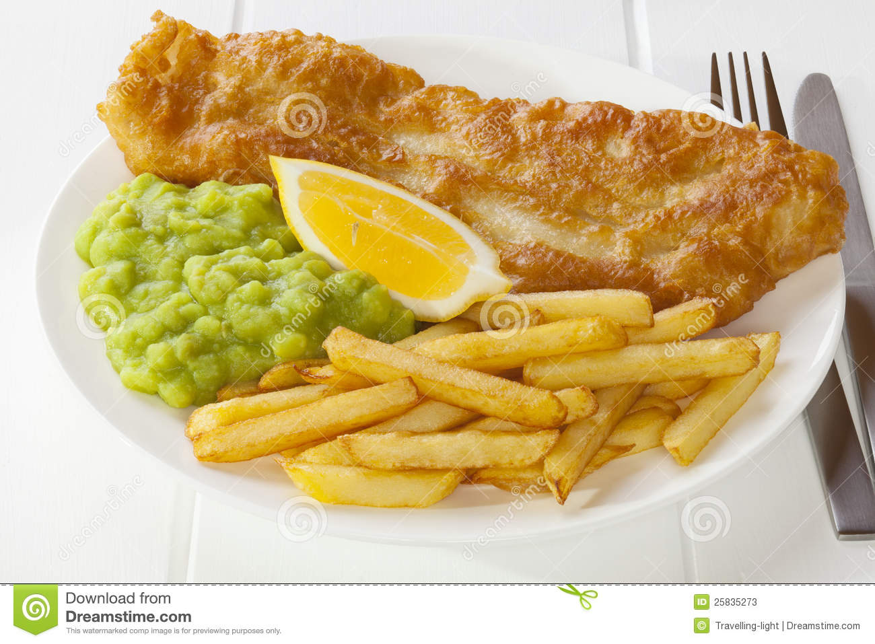

**Havant Margaret Gray**

At the Guild AGM in March there was a change of leadership, the Secretary became Chairman, the Treasurer became Secretary and the Chairman became Treasurer. Thanks were given to all three.

At the monthly meetings members enjoyed talks on The Bench Drama Group, Hadrian’s Wall, William Bunce - a well known Portsmouth man,the Voyage Award and the talk on the Street Pastors was very interesting.Once again Maggie encouraged us to create flower arrangementsand in November members made Christmas cards. Chinese Chequers was played amongst lots of laughter in January. The Division Commissioner attended the Thinking Day meeting when members recalled Guiding memories and those who had influenced their lives.

In May a picnic was held at Sandy Acres with members from Horndean, Emsworth and Hayling Island Guilds joining us. Members attended the County AGM, the Shuffleboard evening, the Sausage Sizzle, the Friendship Service and co-hosted the Christmas Party with Hayling Island Guild. Members attended the “Go Wild” Division event at QE Country Park on a very wet and cold day.

Members held a book stall at the MU coffee morning in October and donated the proceeds to Cystic Fibrosis Kids in Portsmouth. The Guild held a raffle at the Bedhampton District ‘Mothers Day and More’ Craft Afternoon and attended the Youth Service in June. Guild members attended their Quiz evening in October.

We manned a PR stall at the Bedhampton Summer Show and although 2 Ladies took details of the Guild meetings they did not pursue it. Members enjoyed their annual Christmas Lunch in Rowlands Castle hosted by an ex -member of Bedhampton Guides, who made us feel very welcome.

Sadly 2 members died during 2015, Olive Winter in April and Jean French in September, and 2 members are no longer able to attend meetings due to illness.

Thanks to the County for arranging events and to the members of the Guild for their support in my first year as Chairman. My special thanks go to Elizabeth Hobbs, our previous Chair, who has given me so much assistance throughout the year.

Peggy



**Hayling Island Ann Louth**

Our varied programme during 2015 included some extremely interesting talks.

Shortly before her retirement, The Reverend Ann Leonard entertained us with her talk entitled ‘Juggling Churches’. Being responsible for more than one church must have been extremely demanding.

The Seaside Florists of Hayling Island showed us just what could be achieved with the minimum amount of flowers and foliage. Some lucky members were able to take the displays home with them.

Two members of the local Beading Group showed us what could be accomplished with determination and a great deal of patience. Their jewellery and fancy goods were admired by all.

A talk given by new member Hilary Richardson, supported by her husband Ian, on the Northumberland Pipes was particularly enjoyable. They then entertained us with their music.

One of our meetings was entitled ‘To the Beach’. The weather, however, had other ideas – so we took the beach indoors. We painted pebbles, played five stones and had a quiz on birds before finishing with ice creams and the usual tea.

Many of our activities during the year included FOOD – Our Thinking Day Lunch consisted of jacket potatoes and various fillings. We visited the Life Boat Station, followed by tea. We enjoyed a talk and tour of Meadow Farm Nurseries preceded by lunch in their excellent café, and a visit to the Military Museum at Fort Widley, followed by a cream tea at the Armouries. Our annual summer tea at our Chairman’s house was as popular as ever, and finally, an excellent Christmas Lunch at our local golf club was enjoyed by all our members.

Ann

